Industrial & Systems Engineering
Technical Elective Tracks

ISE Elective Tracks for Increased Depth in Select Areas
students admitted to OSU Autumn 2015 or later

In this packet we describe five elective tracks that are available as part of the curriculum for ISE undergraduates in addition to the required set of core courses. These tracks give students an opportunity to acquire greater depth in one of the following areas of specialization:

- Data Analytics & Optimization*
- Supply Chain Management & Logistics*
- Management Systems & Operations Research
- Manufacturing
- Human Systems Integration & Design

In addition to these tracks, students frequently complete coursework and projects to pursue Lean Six Sigma Yellow or Green Green Belt certification, as well as minors in business, computer science, entrepreneurship, or design.
Please contact the ISE Undergraduate Program Coordinator, Katie Bush at bush.537@osu.edu, with questions.
*Students must apply and be accepted to both the Data Analytics & Optimization Track and the Supply Chain Management & Logistics Track prior to beginning the concentration. For deadlines regarding these applications, contact the ISE Advisor listed above.
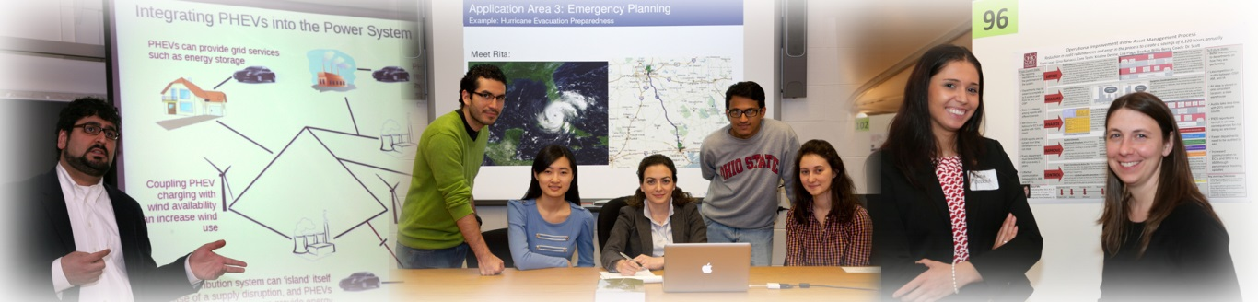
DATA ANALYTICS & OPTIMIZATION
With the big data analytics trend, skills that encompass both data management and business analysis are in great demand. The Data Analytics and Optimization track focuses on using large data sets, computer models, and optimization methods to support data-driven decision-making. This powerful combination of big data analytics with optimization has been successfully demonstrated and will be increasingly needed in the management of:

- healthcare and transportation networks
- retail and financial decision making
- supply chain and logistics systems
- large scale information systems
- manufacturing operations
- energy and smart grids
- social networks

The ISE Data Analytics and Optimization track is an undergraduate elective track designed with a comprehensive and applied curriculum providing students with a strong background in data science, computer science, and optimization methods. The track requires a sequence of courses in computer science, operations research, cognitive engineering, and probability and statistics. Students will be prepared in the use of critical tool sets necessary for managing, visualizing, and extracting useful information from big data, as well as powerful skill sets such for modeling, simulation, optimization, and decision analysis in order to support efficient data-driven decision making.

Entry into this track is competitive, as there is only space for a limited number of students in the required courses. Students will be admitted based on EPHR as well as performance in programming, math, and statistics courses.

It takes a minimum of four semesters to complete this track.
This track requires students to complete a minimum of 17 credit hours.
REQUIRED ELECTIVES (17 hours)
CSE 2221 4 Software I: Software Components (prerequisite CSE 1223)
CSE 2231 4 Software II: Software Development and Design (prerequisite CSE 2221)
CSE 2321 3 Foundations I: Discrete Structures (prerequisite CSE 2221)
CSE 3241 3 Introduction to Database Systems (prerequisite CSE 2231 and CSE 2321)
CSE 5243 3 Introduction to Data Mining (prerequisite CSE 3241 and ISE 3200)

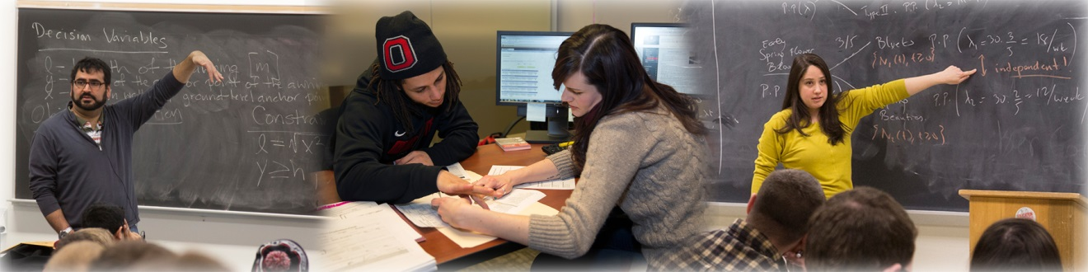

SUPPLY CHAIN MANAGEMENT & LOGISTICS

Complementing their broader background as industrial engineers, the Supply Chain Management & Logistics Track will provide students with an exceptional background for the design and management of supply chains. This includes quantitative modeling of supply chain systems, as well as the use of such modeling to support system design and decision making. Such skills are in great demand for career paths in areas such as healthcare, energy systems, financial management, insurance, manufacturing and production systems, military planning, shipping and distribution, and transportation.
Entry into this track is competitive, as there is only space for a limited number of students in the required courses. Students will be admitted based on EPHR as well as performance in programming, math, and statistics courses.
This track requires students to complete a minimum of 15 credit hours.
REQUIRED ELECTIVES (6 hours)
ISE 5110 3 Design of Engineering Experiments
ISE 5410 3 Quantitative Models in Production and Distribution Logistics
MINIMUM ONE COURSE OF THE FOLLOWING ELECTIVES (3 hours)
ISE 5350 3 Probabilistic Models and Methods in Operations Research
ISE 5830 3 Decision Analysis
ISE technical electives are
not offered every term.
Please review the last page
of this packet for
tentative course offerings.
MINIMUM ONE COURSE OF THE FOLLOWING ELECTIVES (3 hours)
ISE 5682.01 3 Fundamentals of Product Design Engineering
ISE 5760 3 Visual Analytics and Sensemaking
ISE 5800 3 Advanced Project Management
ISE 5810 4 Lean Sigma Foundations
ISE 5820 3 Systems Thinking in Engineering and Design
ISE 5870 3 Resilience Engineering
MINIMUM THREE HOURS FROM THE FOLLOWING ELECTIVES (3 hours)
BUSML 3380 1.5 Logistics Management (prerequisite ISE 2040)
BUSML 4380 1.5 Advanced Logistics Management (prerequisite BUSML 3380)
BUSML 4383 1.5 Supply Chain Management (prerequisite BUSML 3380)
BUSML 4385 1.5 Building a Sustainable Supply Chain (prerequisite BUSML 3380)
BUSML 4387 1.5 Lean Logistics (prerequisite BUSML 3380)
ISE 5350 3 Probabilistic Models and Methods in Operations Research
ISE 5830 3 Decision Analysis
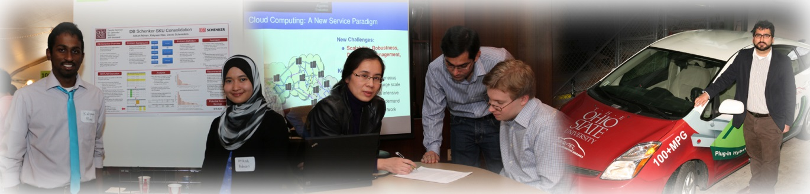
MANAGEMENT SYSTEMS & OPERATIONS RESEARCH

The ISE track in Management Systems will be of interest to students who would like to apply their ISE and Operations Research knowledge and skills to careers paths in areas such as healthcare, energy systems, financial management, manufacturing and production systems, insurance, and transportation. This track includes a focus on logistics, supply chain management, optimization, simulation, lean sigma, logistics and supply chain management, as well as management systems engineering and the design of quality and productivity improvement programs.

This track requires students to complete a minimum of 15 credit hours.
MINIMUM NINE HOURS FROM THE FOLLOWING ELECTIVES (9 hours)
ISE 5043 3 Power Systems: Analysis and Operation
ISE 5110 3 Design of Engineering Experiments
ISE 5220 3 Complementarity Theory and Applications
ISE 5350 3 Probabilistic Models and Methods in Operations Research
ISE 5410 3 Quantitative Models in Production and Distribution Logistics
ISE 5800 3 Advanced Project Management
ISE 5810 4 Lean Sigma Foundations
ISE 5820 3 Systems Thinking in Engineering and Design
ISE technical electives are not offered every term. Please review the last page of this packet for
tentative course offerings.
ISE 5830 3 Decision Analysis
ISE 5870 3 Resilience Engineering

MINIMUM SIX HOURS FROM THE FOLLOWING ELECTIVES (6 hours)
Any ISE technical elective from this track (listed above)
Any ISE technical elective from the Manufacturing track (page five)
Any ISE technical elective from the Human Systems Integration & Design track (page six)
Any outside approved elective (page seven)

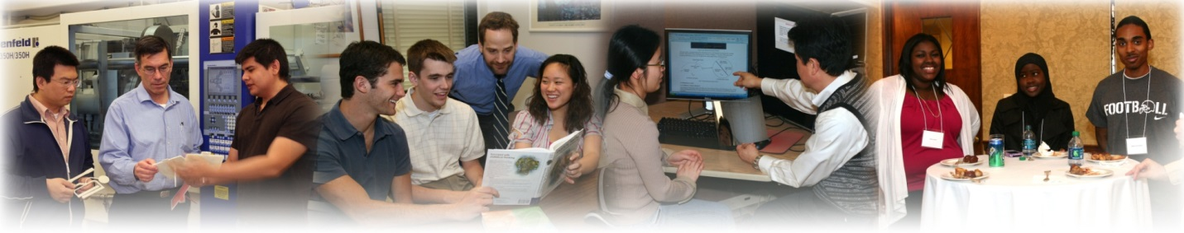

MANUFACTURING
Students interested in the transformation of raw materials into commercially successful products might consider the ISE Manufacturing Engineering track. The curriculum in Manufacturing Engineering exercises students’ background in chemistry, physics, and mathematics toward the understanding and improvement of manufacturing materials, processes, and systems. Courses focus on process engineering, design for manufacturability, design of work-holding/dies/molds, numerical (computer) simulation, and automation/robotics as applied to machining processes, sheet forming operations, metal casting, and polymer processing.
ISE technical electives are not offered every term. Please review the last page of this packet for
tentative course offerings.

This track requires students to complete a minimum of 15 credit hours.
REQUIRED ELECTIVE (3 hours)
ISE 3500 3 Process Engineering for Machining Operations

MINIMUM SIX HOURS FROM THE FOLLOWING ELECTIVES (6 hours)
ISE 5520 1.5 Industrial Automation
ISE 5521 1.5 Advanced Sheet Forming Laboratory
ISE 5525 1.5 Industrial Robotics
ISE 5540 3 Polymer Processing Fundamentals
ISE 5550 3 Principles of Precision Engineering
ISE 5555 3 Manufacturing Processes and Machine Tools
ISE 5682.01 ª 3 Fundamentals of Product Design Engineering
ISE 5683 1 Fundamentals of Product Design Engineering Lab
MATSCEN 5451 3 Molten Metal Processing

MINIMUM SIX HOURS FROM THE FOLLOWING ELECTIVES (6 hours)
Any ISE technical elective from this track (listed above)
Any ISE technical elective from the Management Systems & Operations track (page four)
Any ISE technical elective from the Human Systems Integration & Design track (page six)
Any outside approved elective (page seven)

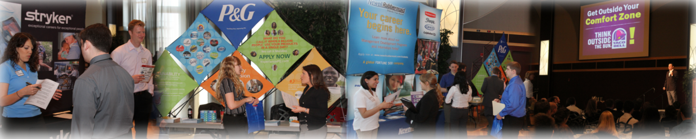

HUMAN SYSTEMS INTEGRATION & DESIGN
The ISE track in Human Systems Integration & Design will be of interest to students who are “people-oriented” and are interested in designing work and work systems that rely on and/or support human performance. Students interested in product design will also find this track valuable. All types of operations can benefit from improvements in Human Systems Integration & Design, including companies involved in:
- healthcare
- transportation
- energy management
- information management
- retail and financial systems
- manufacturing and production systems.

This track in Human Systems Integration & Design focuses on strategies for improving productivity, quality, resilience and safety. In addition to general courses on human factors engineering and design, it includes courses
concerned with occupational safety and health, as well as courses concerned with cognitive systems engineering.
ISE technical electives are
not offered every term.
Please review the last page
of this packet for
tentative course offerings.
This track requires students to complete a minimum of 15 credit hours.
MINIMUM NINE HOURS FROM THE FOLLOWING ELECTIVES (9 hours)
ISE 5110 3 Design of Engineering Experiments
ISE 5610 3 Ergonomics in the Product Design Process
ISE 5620 3 Risk Assessment Tools for Occupational Musculoskeletal Disorders
ISE 5640 3 Occupational Safety: Analysis and Design of Work Environments
ISE 5682.01 ª 3 Fundamentals of Product Design Engineering
ISE 5683 1 Fundamentals of Product Design Engineering Laboratory
ISE 5710 3 Behind Human Error: Safety and Complex Systems
ISE 5740 3 Cognitive Engineering Systems: Human-Centered Automation
ISE 5760 3 Visual Analytics and Sensemaking
ISE 5820 3 Systems Thinking in Engineering and Design
ISE 5870 3 Resilience Engineering
MINIMUM SIX HOURS FROM THE FOLLOWING ELECTIVES (6 hours)
Any ISE technical elective from this track (listed above)
Any ISE technical elective from the Management Systems & Operations track (page four)
Any ISE technical elective from the Manufacturing track (page five)
Any outside approved elective (page seven)
OUTSIDE APPROVED ELECTIVES
*Pre-Requisites for each course still apply and MUST be met in order to enroll in the following courses*
This information can be viewed by searching the Course Catalog or Syllabus Search Tool.
ACCTMIS 2000 (3) | CIVILENG 3510 (3) | DESIGN 2700 (3) | CHEM 2310 (4)
ACCTMIS 2200 (3) |  | DESIGN 3105 (3) | CHEM 2510 (4)
 | ECE 2000 (4) | DESIGN 3305 (3)
BUSADM 3531 (3) | ECE 2020 (3) | DESIGN 4405 (3) | MATH 2366 (2)
BUSADM 3532 (3) | ECE 2060 (3) | DESIGN 4505 (3) | MATH 4512 (3)
BUSADM 3533 (3) |  | DESIGN 5405 (3) | MATH 4530 (3)
BUSADM 4510 (3) | ENGR 4692.02S (3) | DESIGN 5505 (3) | MATH 4551 (3)
 | ENGR 5050 (3) |  | MATH 4552 (3)
BUSFIN 3120 (3) |  | PSYCH 3310 (3)
BUSINF 3220 (3) | FABE 5200 (3) | PSYCH 3312 (3) | STAT 5510 (3)
 |  | PSYCH 3313 (3) | STAT 5550 (3)
BUSMGT 3130 (3) | MATSCEN 2010 (3) | PSYCH 3325 (3)
BUSMGT 3230 (3) | MATSCEN 2251 (3) | PSYCH 4508 (3) | NAVALSC 3110 (3)
BUSMGT 4232 (3) |  |  | NAVALSC 3210 (3)
BUSMGT 4233 (3) | MECHENG 2030 (3) | PUBHEHS 3310 (3)
BUSMGT 4239 (3) | MECHENG 5665 (3) | PUBHEHS 3320 (3) | any CSE course numbered
BUSMGT 4240 (3) | MECHENG 5666 (3) | PUBHEHS 5325 (3) | 2113 or above
BUSMGT 4242 (3) | MECHENG 5680 (4)
 | MECHENG 5682.01 (3) | PUBHLTH 5015 (3)
BUSMHR 3100 (3) | MECHENG 5716 (3)
BUSMHR 3510.01 (3) |  | The following courses are approved only if the additional  science requirement for the major is already completed:
BUSMHR 5530 (3)
BUSML 3150 (3) |  | ANATOMY 2220 (4) | EARTHSC 1911 (4)
BUSML 3380 (1.5) |  | ANATOMY 2300 (4) | EARTHSC 2155 (3)
BUSML 4380 (1.5) |  | ANATOMY 3300 (5) | EARTHSC 2203 (3)
BUSML 4382 (3) |  | ANTHROP 2200 (4) | EARTHSC 2204 (3)
BUSML 4383 (1.5) |  | BIOLOGY 1113 (4) | EARTHSC 3203 (3)
BUSML 4385 (1.5) |  | BIOLOGY 1114 (4) | ENR 2155 (3)
BUSML 4387 (1.5) |  | BIOLOGY 2100 (4) | ENR 3280 (2)
BUSML 4388 (1.5) |  | CHEM 1210 (5) | EEOB 2510 (3)
BUSML 5389 (3) |  | CHEM 1220 (5) | EEOB 2520 (3)
 |  | CHEM 1250 (5) | GEOG 2200 (3)
 |  | PHYSICS 3700 (3) | GEOG 3300 (3)
ISE TECHNICAL ELECTIVES – COURSE OFFERING PLAN
KEY
X | offered every year
XO | offered in odd years only (2017, 2019, 2021)
XE | offered in even years only (2016, 2018, 2020)
These are the normal semesters of offering.
While we try our best to offer courses on their regular schedule, please note that semesters of offering may change.

COURSE | HOURS | TITLE | AUTUMN | SPRING
ISE 3500 | 3 | Process Engineering for Machining Operations | X | X
ISE 5043 | 3 | Power Systems: Analysis and Operation |  | XE
ISE 5110 | 3 | Design of Engineering Experiments |  | X
ISE 5220 | 3 | Complementarity Theory and Applications |  | XO
ISE 5350 | 3 | Probabilistic Models and Methods in Operations Research |  | X
ISE 5410 | 3 | Quantitative Models in Production and Distribution Logistics | X
ISE 5520 | 1.5 | Industrial Automation | X | X
ISE 5521 | 1.5 | Advanced Sheet Forming Laboratory |  | X
ISE 5525 | 1.5 | Industrial Robotics | X | X
ISE 5540 | 3 | Polymer Processing Fundamentals |  | X
ISE 5550 | 3 | Principles of Precision Engineering |  | XE
ISE 5555 | 3 | Manufacturing Processes and Machine Tools |  | XO
ISE 5610 | 3 | Ergonomics in the Product Design Process | X
ISE 5620 | 3 | Risk Assessment Tools for Occupational Musculoskeletal Disorders |  | XO
ISE 5640 | 3 | Occupational Safety: Analysis and Design of Work Environments | XE
ISE 5682.01 | 3 | Fundamentals of Product Design Engineering | X | X
ISE 5683 | 1 | Fundamentals of Product Design Engineering Lab | X | X
ISE 5710 | 3 | Behind Human Error: Safety and Complex Systems |  | XE
ISE 5740 | 3 | Cognitive Engineering Systems: Human-Centered Automation |  | XO
ISE 5760 | 3 | Visual Analytics and Sensemaking |  | X
ISE 5800 | 3 | Advanced Project Management | X | X
ISE 5810 | 4 | Lean Sigma Foundations | X | X
ISE 5820 | 3 | Systems Thinking in Engineering and Design | XO
ISE 5830 | 3 | Decision Analysis | no set offering plan
ISE 5870 | 3 | Resilience Engineering | X
MATSCEN 5451 | 3 | Molten Metal Processing |  | X

